Week 4: Deployment Plan

Report Link: https://app.powerbi.com/links/Q08e0lir2X?ctid=56c1d497-700b-49cf-8f8d-3dd6b20d522f&pbi_source=linkShare
Final Report: Used Power BI Service to publish the report for users, created workspaces and deployment pipeline for version control.
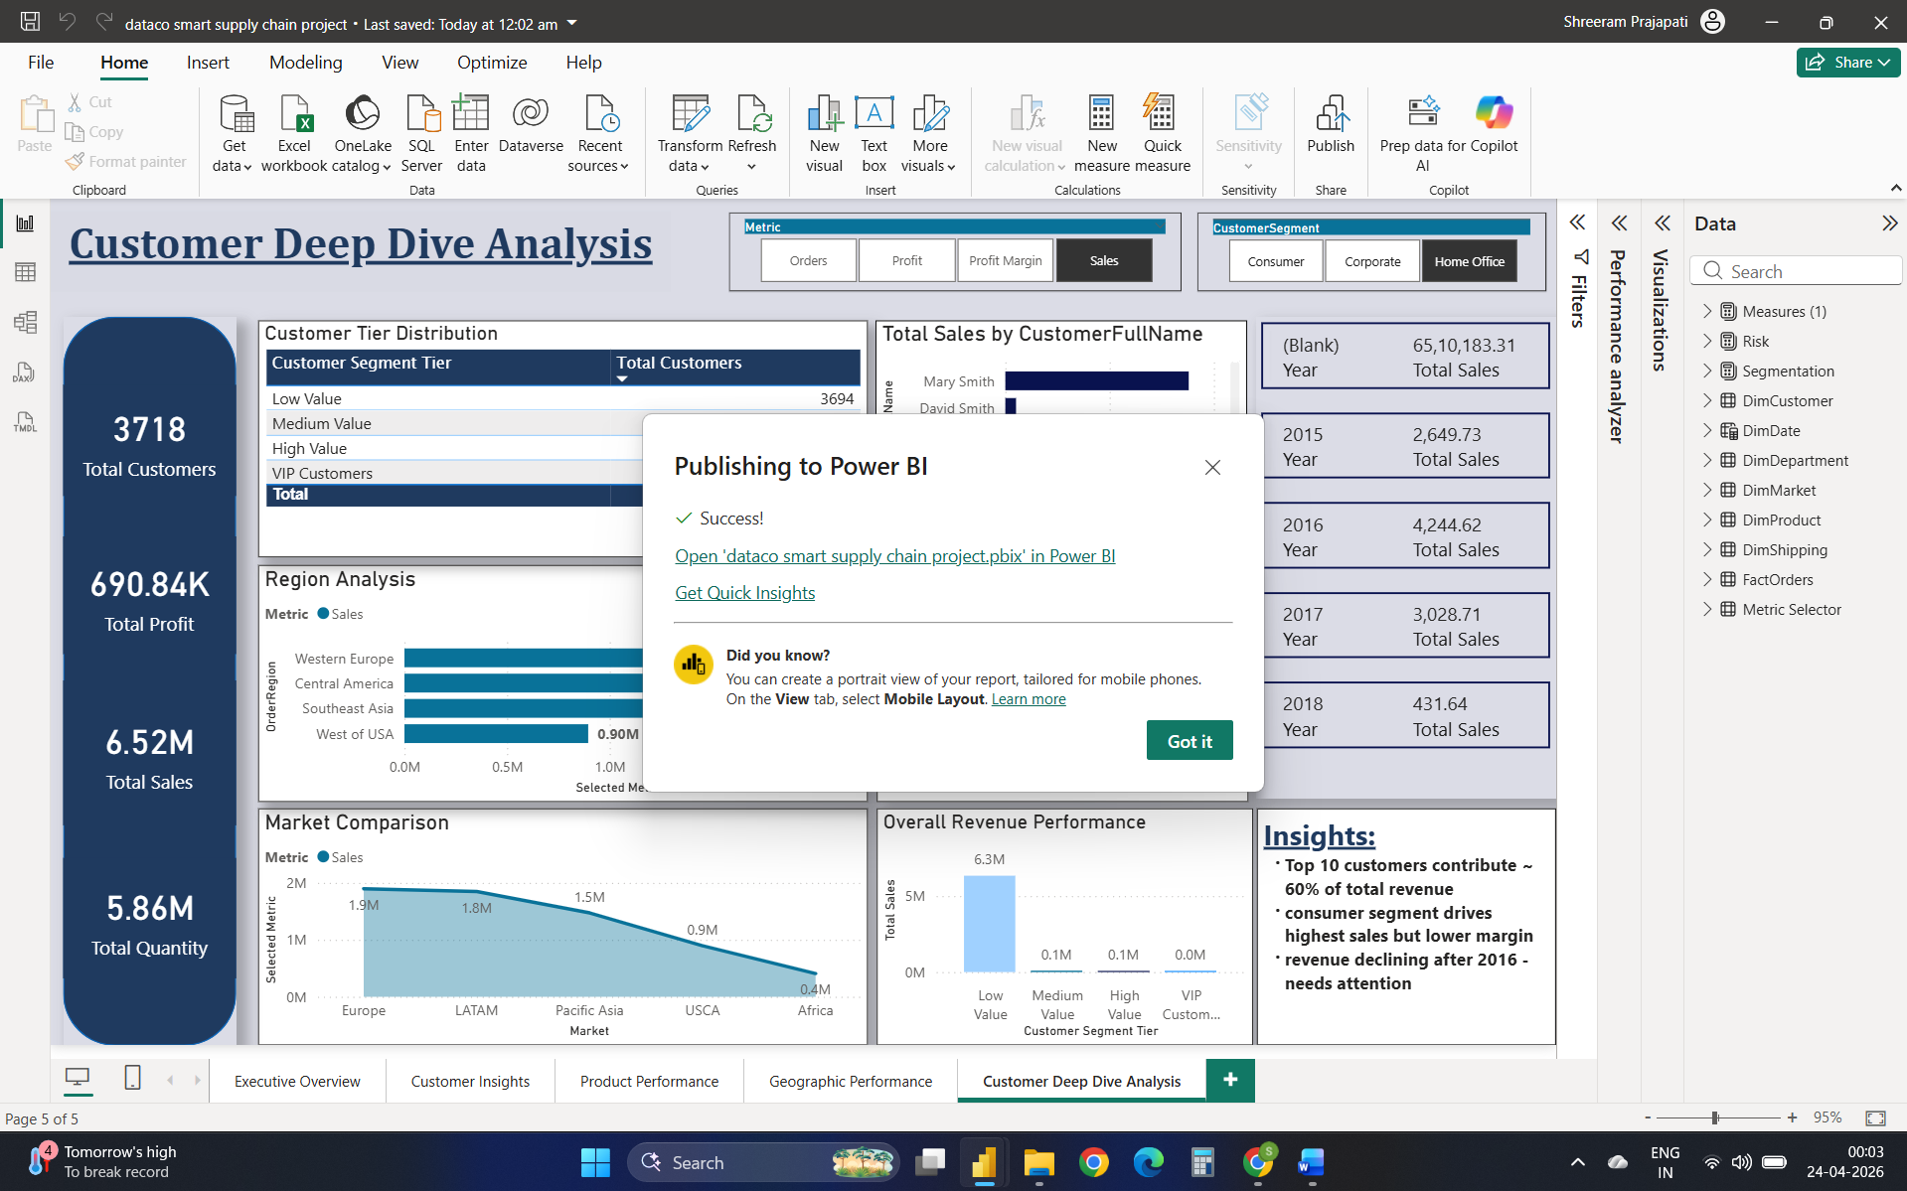
Dev Environment: Report are built and tested by us before sharing.
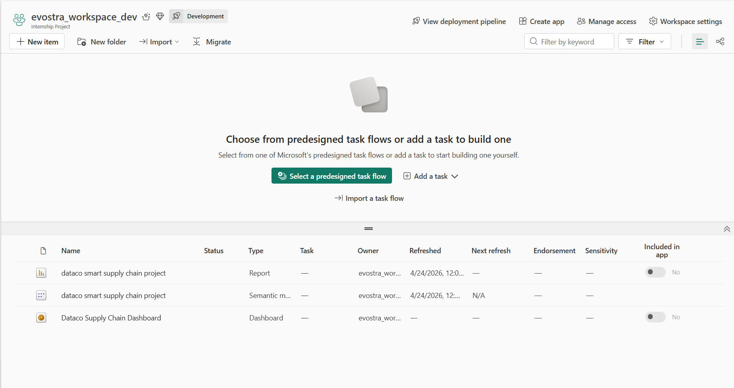
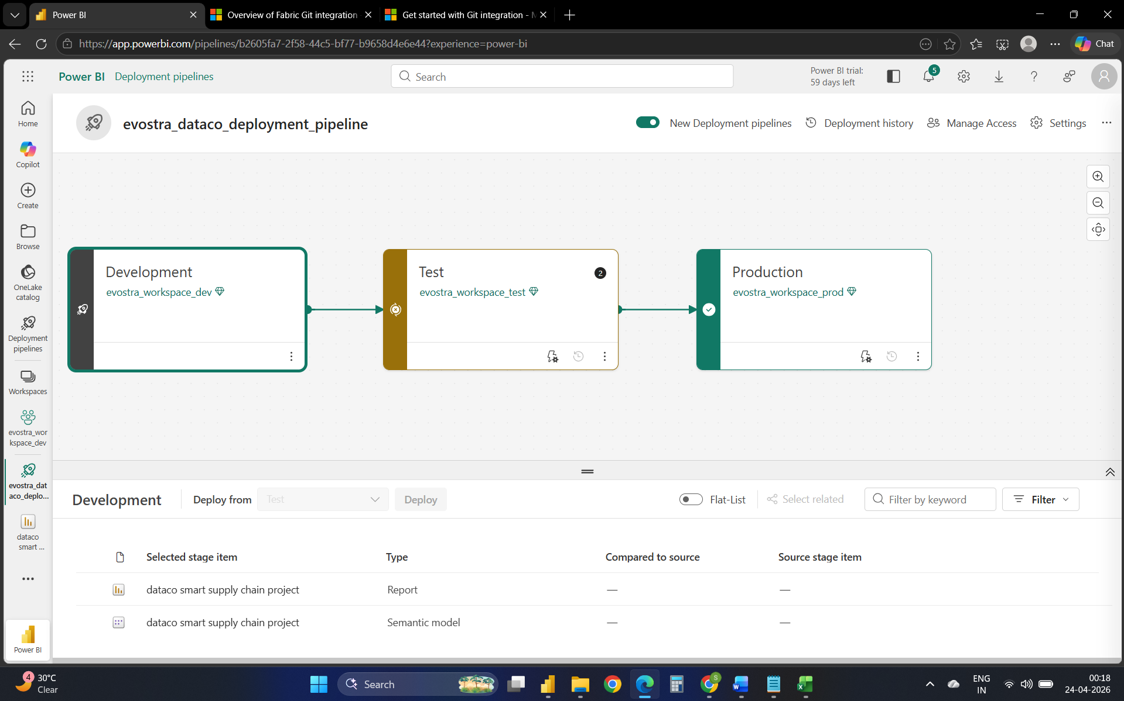
Test Environment: Reports are validated with sample users to ensure accuracy and performance.
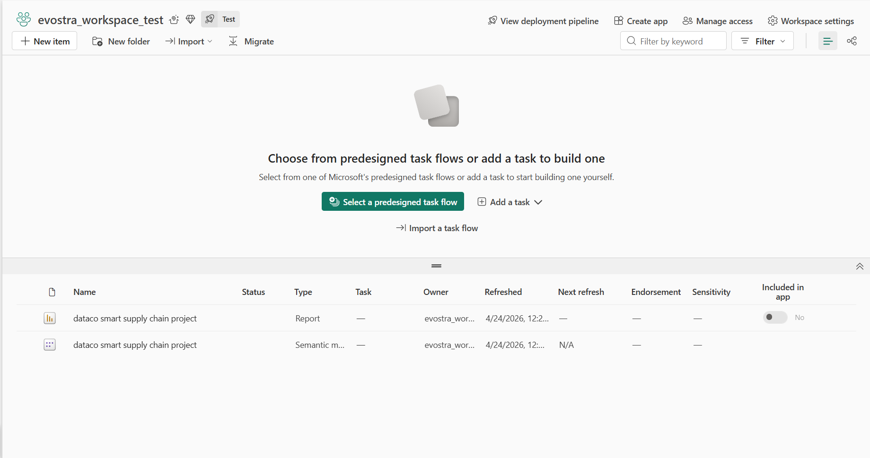
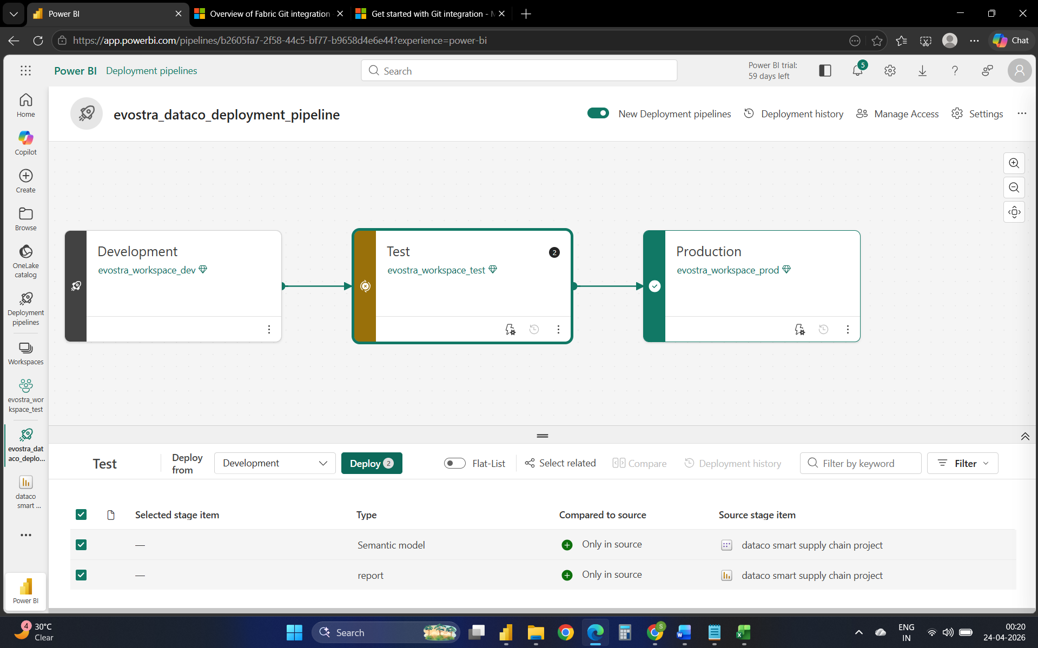
Production Environment: Where final reports are published for business use and daily decision-making.
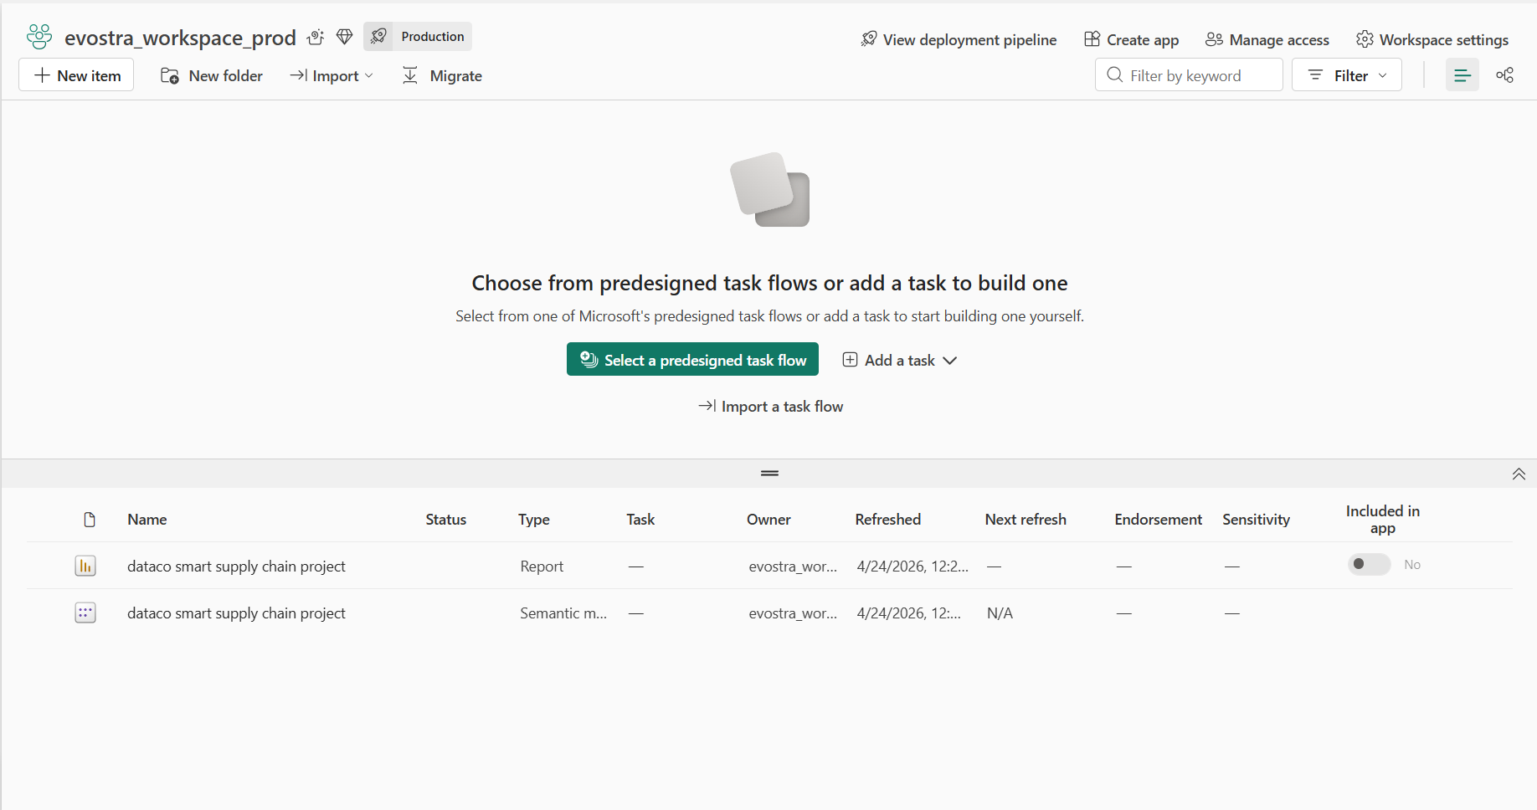

Deployment pipeline: evostra_dataco_deployment_pipeline
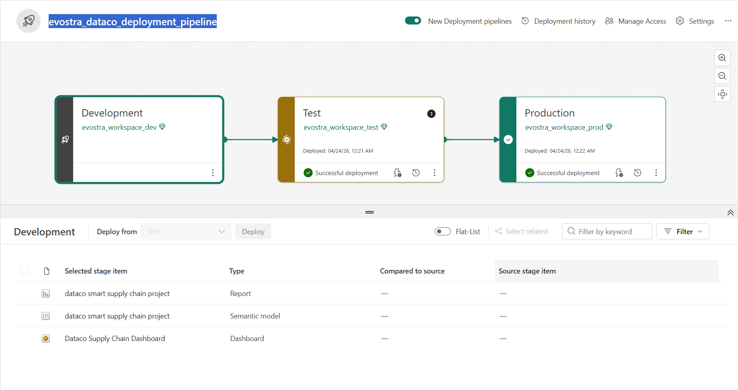
Deployment History:
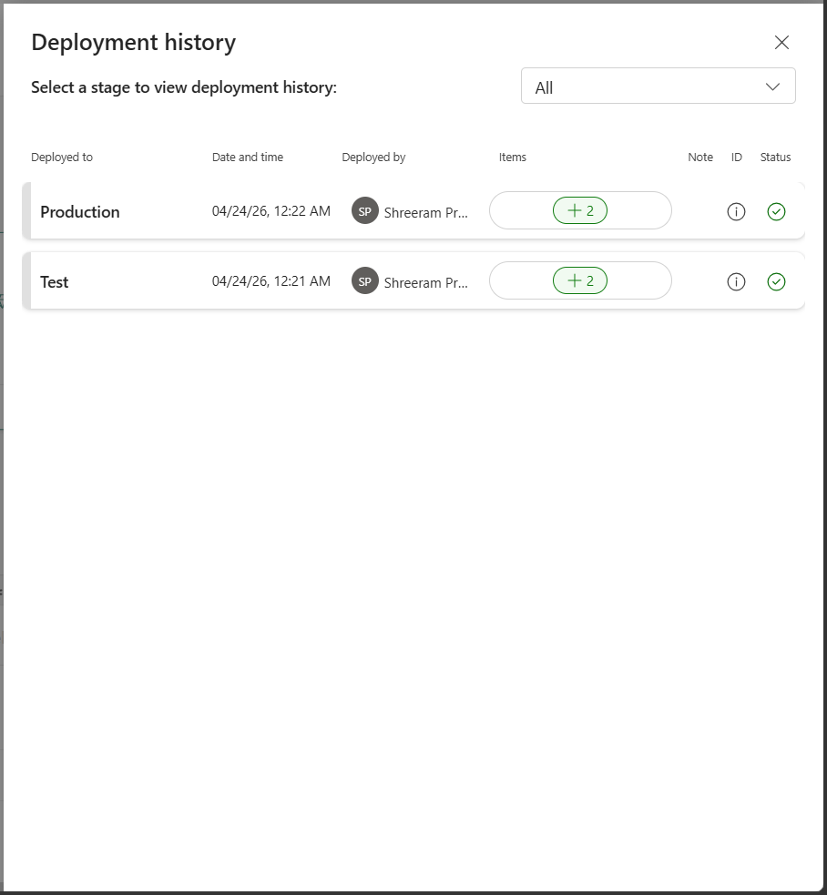
Lineage View: A visual map that shows where the data comes from, how it flows through datasets, and which reports or dashboards depend on it.
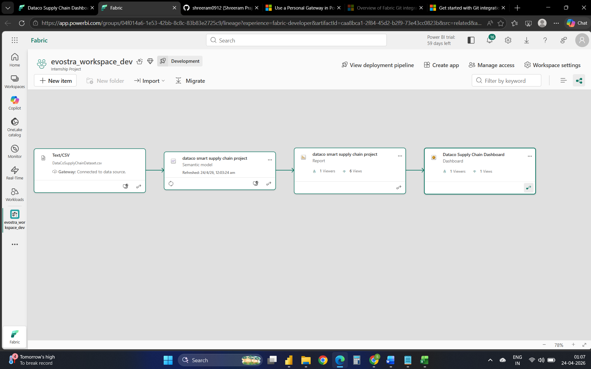

Dashboard Mobile Layout:
